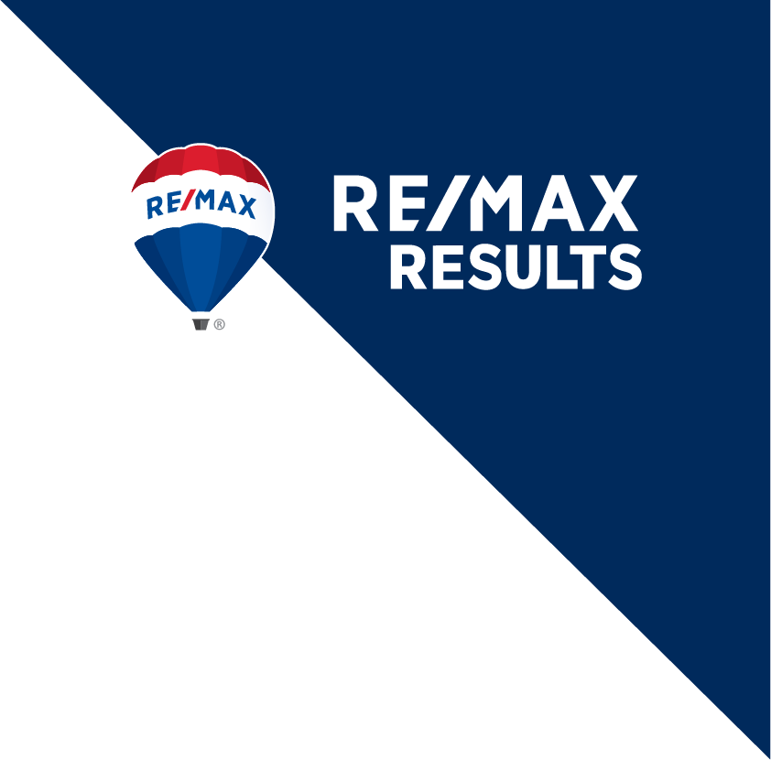

**JOB POSITION:** Front Desk Administrative Assistant

**PRIMARY LOCATION:** Hudson, WI

**POSITION HOURS:** Mon – Fri, 8AM – 5PM (one-hour unpaid break)

**POSITION STATUS:** Full-time,Hourly, Non-exempt

**AVAILABILITY:** Immediate

# RE/MAX Results is the largest RE/MAX franchise in the United States and the largest privately held brokerage in Minnesota. With 42 office locations and over 1,300 Sales Executives throughout Minnesota and western Wisconsin, we are committed to serving our agents and their real estate business.

# The front desk administrative assistant is the most visible function in the office and is responsible for handling all front office duties cheerfully, competently, and professionally.

# JOB DESCRIPTION AND RESPONSIBILITIES (include, but are not limited to):

* Answer RingCentral multi-line telephone system, redirect calls, and take messages
* Schedule and confirm showing requests including proper documentation on ShowingTime, our e-showing appointment software
* Greet customers and guests (in-office presence, required)
* Attend to associate questions and requests including appropriate follow-up
* Distribute mail in a timely manner
* Attend to office equipment, resource rooms, and conference rooms
* Enter new listings in MLS, a national database, and execute the listing lifecycle process
* Edit existing listings in MLS, per written instructions received by listing associate
* Retrieve, document, and follow-through on messages left on the appointment line
* Assist associates with various office equipment.

# KNOWLEDGE, SKILLS AND ABILITIES:

* Excellent and proven customer service experience
* Experience answering multi-line telecommunication system
* Quick learning style with the ability to multi-task in a fast-paced office environment and adjust pace accordingly
* Demonstrate ability to deliver consistent, committed, reliable, and timely performance
* Professional appearance and demeanor
* Desire long-term position (1 year or longer)
* Team player
* Common sense approach to problem solving
* Reliable transportation
* Punctual and responsible with respect to managing commitments
* Business professional attire

**Compensation**: Pay is commensurate with experience and qualifications plus a comprehensive benefits package including medical, dental, vision, short term disability, accident, critical, life insurance, 401k Savings and Retirement, and Wellness Program.

If you are interested in applying for this position, please send your cover letter and resume to: [Jobs_8@results.net](mailto:Jobs_8@results.net)

*RE/MAX Results is an EOE. We are committed to hiring individuals who contribute to the cultural diversity of our workplace. Employment at RE/MAX Results is based solely on a person’s merit and qualifications directly related to professional competence. Our hiring decisions are guided by our equity value; embracing differences, seeking to eliminate racism and other forms of discrimination, and striving to create a workplace in which everyone matters.*